**Study on association of air polluants with epidemic trend of hemorrhagic fever with renal syndrome in Zhejiang province**

**浙江省空气污染物与肾综合征出血热流行趋势的相关性研究**

A THESIS

SUBMITTED TO SCHOOL OF MATHEMATICS & PHYSICS

OF XI ’AN JIAOTONG-LIVERPOOL UNIVERSITY

IN PARTIAL FULFILMENT FOR THE AWARD OF THE DEGREE OF

MSc Financial Mathematics

By

Chenxia Liu 2254321

Supervisor: Dr. Mu He

November 27, 2023



Study on association of air polluants with epidemic trend of hemorrhagic fever with renal syndrome in Zhejiang province

# Abstract

From 2005 to 2020, Zhejiang Province in China reported 7,724 cases of Hemorrhagic Fever with Renal Syndrome (HFRS), resulting in 25 deaths. The incidence exhibited two annual peaks in winter (November–January) and late spring to early summer (May–June). Taizhou, Shaoxing, and Ningbo were the areas with the highest cumulative instances. The male-to-female ratio was 2.73∶1, and the majority of cases affected middle-aged and older individuals, with farmers constituting 69.89% of cases. Analysis from 2013 to 2020 linked HFRS resurgence to environmental factors, including air pollutants and meteorological variables. A moderate correlation was found between HFRS and monthly Air Quality Index, Nitrogen Dioxide, and Sulfur Dioxide, while a negative correlation existed with temperature. Spatial distribution patterns were observed, but the study emphasized correlation rather than establishing causation.

从2005年到2020年，中国浙江省共报告了7724例出血热伴肾综合征（HFRS）病例，造成25人死亡。每年冬季（11 月至 1 月）和春末夏初（5月至6月）是发病高峰。台州、绍兴和宁波是累计发病率最高的地区。 男女比例为2.73∶1，中老年人占多数，农民占69.89%。从2013年到2020年的分析显示，HFRS 复发与环境因素有关，包括空气污染物和气象变量。研究发现，HFRS与每月空气质量指数、二氧化氮和二氧化硫之间存在中度相关性，而与气温之间存在负相关。与此同时也观察到了空间分布模式，但研究强调的是相关性，而不是确定因果关系。

**KEY WORDS:**HRFS trend,Demographic Insights,Geographical Correlations,Environmental Factors

关键词:HRFS趋势，人口统计学见解，地理相关性，环境因素

# Introduction

From 2005 to 2020, Zhejiang Province recorded 7,724 instances of hemorrhagic fever with renal syndrome (HFRS), which resulted in 25 fatalities. Every year, there were two peaks in the incidence: one in the winter (November–January) and one in the late spring and early summer (May–June). The areas with the largest cumulative instances were Taizhou (1,642, 21.25%), Shaoxing (1,123, 14.54%), and Ningbo (1,875, 24.27%). The male-to-female ratio among the instances that were recorded was 2.73∶1 (5,656∶2,068). The bulk of HFRS instances affected middle-aged and older people (60.95% of cases), with the majority of those afflicted being between the ages of 41 and 70. Farmers accounted for 69.89% (5,398 out of 7,724) of all HFRS cases. Most years showed a correlation between the spatial distribution of HFRS cases.

Hemorrhagic Fever with Renal Syndrome (HFRS) has experienced a resurgence in China since 1963, with environmental factors being identified as potential contributors. In our analysis, data encompassing the years 2013 to 2020 were scrutinized, focusing on six air pollutants and meteorological variables, including temperature and humidity. Notably, a low to moderate correlation was observed between HFRS incidence and monthly Air Quality Index (AQI) (r = 0.27), Nitrogen Dioxide (NO₂) (r = 0.42), and Sulfur Dioxide (SO₂) (r = 0.25). Additionally, a negative correlation was noted with temperature (r = -0.22). Spatial autocorrelation was further assessed using the Moran test, revealing patterns in the geographical distribution of HFRS cases. It is essential to emphasize that while correlations were identified, a direct causative relationship has not been established through our analysis.

# Literature Review

Hemorrhagic fever with renal syndrome (HFRS), caused by different hantaviruses such Hantaan (HTNV), Seoul (SEOV), Dobrava-Belgrade virus, Saaremma, and Puumala, is a global health concern. Human-to-human transmission of HFRS is rare; instead, the disease is primarily spread by direct contact with aerosolized rodent droppings or bodily fluids. Clinical signs and symptoms include shock, thrombocytopenia, hypotension, vomiting, fever, and abdominal aches.

In eastern Asia, particularly in China, Russia, and Korea, the hantaan virus is common. The puumala virus has been found in western Russia, Scandinavia, and Europe. The Seoul virus is spread throughout the world, while the Dobrava virus is mostly found in the Balkans. Scandinavia and central Europe are home to Saaremaa. A unique illness known as hantavirus pulmonary syndrome is caused by hantaviruses in the Americas.

The analyzed data on HFRS cases in Zhejiang province during 2005-2020 were collected from Zhejiang Provincial Center for Disease Control and Prevention (CDC). For a descriptive analysis, The study consisted of 7724 HFRS in China from 2004 to 2020. The data contains the basic characteristic like age, gender living addresses, occupations and the year of diagnostics and illness. Since in year 2004 we only get few data, we think it is measurement problem. So, we exclude that from our analysis later. Zhejiang has an population of 64,567,588 in 2020. The geographical scope of our study encompasses the main cities, specifically Hangzhou, Huzhou, Jiaxing, Jinhua, Lishui, Ningbo, Quzhou, Shaoxing, Taizhou, Wenzhou, and Zhoushan. These cities might eventually be further subdivided into county levels for more detailed analysis.

This research also investigates the impact of diverse factors, including environmental, meteorological factors, on the incidence of infectious diseases. Monthly air quality data, including the Air Quality Index (AQI) and concentrations of pollutants such as PM2.5, PM10, SO₂, NO₂, CO, and O₃, were obtained from National Air Quality Monitoring Stations in China. The study specifically examines the spatio temporal clustering distribution characteristics and trends in HFRS outbreaks in Zhejiang Province. The findings contribute valuable data for a comprehensive exploration of the epidemiological characteristics and influencing factors of HFRS. Furthermore, the results inform the development of predictive warning models and strategies for precise control of HFRS. The multifaceted analysis enhances our understanding of the intricate dynamics influencing the occurrence of infectious diseases. The heat map shows seasonal patterns, which mean the HFRS showed semiannual peaks of activity, including a peak in May and June followed by a peak in November and December. HFRS predominantly locally circulated in the north, northeast, and northwest of Zhejiang.

The nationwide monthly mean concentrations for PM2.5, PM10, SO₂, NO₂, and CO were 51.28 μg/m3, 90.75 μg/m3, 24.35 μg/m3, 33.63 μg/m3, and 1.08 mg/m3, respectively, from 2013 to 2018. The mean concentration for O₃ during the daylight 8-hour period was 86 mg/m3. The PM2.5 and PM10 monthly concentrations were higher than the level specified in China Guidelines II for 2018. A clear seasonal pattern was shown in boxplots showing monthly variation in air pollution concentrations. We observe a noteworthy correlation among various air pollutants, indicating a level of interdependence. This suggests that the presence or concentration of one air pollutant is associated with the behavior or characteristics of others. However, temporal variations were evident in their trends. The average monthly concentrations of PM2.5, PM10, and CO experienced a significant annual decrease. In contrast, O₃ values demonstrated a notable increase over the 6-year period (2013–2018), while NO₂ exhibited a volatile upward trend from 2016 onward, following a declining pattern during 2013–2016. Besides, concentrations of NO₂ and O₃ were positively correlated with HFRS incidences in quantile groups. Meteorological data, including temperature and humidity, were also collected for analysis.

In the realm of public health, understanding the spread of infectious diseases is crucial for effective prevention and control measures. Recent studies have delved into the intricate dynamics of epidemics by employing sophisticated spatiotemporal modeling techniques. These approaches not only provide insights into the geographical patterns of disease transmission but also unravel the temporal aspects that influence the course of an outbreak. There are also various studies focusing on the epidemiology of infectious diseases with spatio-temporal modeling. Spatio temporal modeling in epidemiology involves the integration of space (geographical location) and time into the analysis of disease spread. This multidimensional approach enables researchers to discern patterns, identify hotspots, and predict the trajectory of infectious diseases more accurately. By incorporating geographical information systems (GIS). Creating models that capture the complex interplay between space and time in the context of disease dynamics. One key aspect of spatio temporal modeling is the exploration of geographical patterns in disease transmission. can By mapping the spatial distribution of cases, revealing clusters or areas with higher vulnerability. Understanding how diseases propagate across different regions allows for targeted interventions, resource allocation, and the development of region-specific public health strategies. The integration of spatio temporal modeling in epidemiology also empowers to develop predictive models. These models can forecast the spread of diseases based on current trends, environmental factors, and population dynamics. Such foresight enables public health authorities to implement preventive measures in advance, potentially mitigating the severity of an outbreak and reducing its impact on communities. Nazia N et al [14] analyzed the spread of the COVID-19 pandemic by examining 154 peer-reviewed publications on the disease that used a variety of Bayesian and Frequentist spatial methods to identify geographic variations in the risk of contracting the disease and the socioeconomic, demographic, and climatic factors that are related to these geographic variations in risk.

Epidemiology has a rich tradition of investigating factors that influence the fluctuation in the occurrence or fatality rates of infectious and chronic diseases. Among these factors, geographical or spatial variances in health outcomes play a pivotal role in assessing the distribution and effectiveness of healthcare. These spatial variations not only provide crucial insights into patterns of dependence and noise levels in the data but also serve as a foundation for appraising healthcare performance.

Liu et al.(2019) utilized the Autoregressive Integrated Moving Average (ARIMA) model to evaluate and forecast HFRS incidence in China, employing historical time series data. Although the ARIMA model proves beneficial for estimating continuous time series data, it tends to overlook correlations among different spatial locations.

Recognizing this limitation, Santosha Rathod (2018)[13]presented an enhanced version of the Space-Time Autoregressive Moving Average (STARMA) model for time-series data modelling and forecasting in space and time.However, it is crucial to note that the STARMA model treats the spatial influences of data in distinct locations as individual factors. To improve the precision of spatial epidemic analysis, particularly in the context of HFRS, a more comprehensive strategy involves considering both spatial and temporal characteristics, incorporating interactive influences. This integrative approach holds the potential to contribute to a more nuanced comprehension of the dynamics underlying HFRS outbreaks.

# Data collection and method

All statistical analyses were performed using R (version 4.3.1, R Foundation for Statistical Computing, Vienna, Austria). A p-value of <0.05 was considered statistically significant. The geographic information are downloaded by using the raster package (Hijmans 2022a), which allows free downloading of national administrative boundary information from the GADM website, which can be used for academic and non-commercial purposes. It provides administrative boundary data at the national, provincial, municipal, and county levels, which can be directly downloaded and imported into the R environment.

1. Descriptive analyses

We used quartiles (P25, median, P75), mean, standard deviation, and other metrics to describe the distribution of HFRS incidence, air contaminants, and climatic factors. Descriptive methods were used to analyse the epidemiological features of HFRS cases, such as geographic distribution, seasonal pattern, gender, age, and employment.

1. Mann-Kendall Testing

The Mann-Kendall test is a non-parametric, rank-based test that is commonly used in environmental sciences to determine whether or not there is a monotonic trend in a timeseries. The assumption that you need to consider before using Mann-Kendall is that there is no seasonality in the dataset (there is a seasonal Kendall test that you can use for timeseries collected over mutliple seasons).

The test statistic is calculated by:

$$S=\sum_{i=1}^{n−1}{ }\sum_{j=i+1}^{n}{ }sign⁡\left(y_{j}−y_{i}\right)$$

Where the $sign⁡\left(y_{j}−y_{i}\right)$ is equal to 1 when $y_{j}>y_{i},0$ when $y_{j}=y_{i}$, and -1 when $y_{j}<y_{i}$

We then use this statistic to calculate Kendall's rank coefficient $(τ)$ value:

$$τ=\frac{S}{n(n−1)}$$

This $τ$ value ranges between -1 and 1 . A $τ$ of 0 indicates no trend whereas a $τ$ of -1 or 1 indicates a perfectly negative or positive trend respectively.

1. Anova Test

The Analysis of Variance (ANOVA) test is a statistical method used to assess whether the means of two or more groups are significantly different from each other. It is particularly valuable when comparing means across multiple levels of a categorical variable. The ANOVA test achieves this by partitioning the total variance in the data into different components associated with each group. The approach aimed to examine the time differences between diagnostics and illness onset.

The hypotheses of interest in an ANOVA are as follows:

$H_{0}:μ_{1}=μ_{2}=μ_{3}…=μ_{k}$

* $H_{1}$:Means are not all equal.  
  where $k=$ the number of independent comparison groups.

1. Correlation plot

A measure of the linear correlation between two sets of data is the Pearson correlation coefficient. It yields a normalised measure of covariance and is calculated as the ratio of two variables' covariance to the product of their standard deviations.1

$$r=\frac{\sum{ }\left(x_{i}−\overset{‾}{x}\right)\left(y_{i}−\overset{‾}{y}\right)}{\sqrt{\sum{ }{\left(x_{i}−\overset{‾}{x}\right)}^{2}\sum{ }{\left(y_{i}−\overset{‾}{y}\right)}^{2}}},$$

Where:

* $x_{i}$ and $y_{i}$ are your data points,
* $\overset{‾}{x}$ is the mean of the $x$-values and $\overset{‾}{y}$ is the mean of the $y$-values,
* $∑$ is the summation sign, see sigma notation for more information.

To show the relationship between various elements, we also used correlation plots. The correlation plot, commonly referred to as a heatmap or correlation matrix, is a popular tool for visualising the correlation coefficients between variables in a dataset. When attempting to discern dependencies, trends, and interactions between various variables, the correlation plot is especially helpful. The correlation coefficient quantifies the degree and direction of a linear link between two variables. Its values vary from -1 to 1, with 1 denoting perfect negative correlation, 1 denoting perfect positive correlation, and 0 denoting no correlation. When there is a strong positive correlation between two variables, it indicates that when one rises, the other also tends to rise. When there is a strong negative correlation, it means that the two variables tend to go down as one rises.

1. The global spatial autocorrelation analysis

By calculating Moran's I statistic (Moran 1950) and doing a permutation test, we may determine the degree of spatial autocorrelation present in the residuals from this model. Using the moran.mc() function from the spdep package in R, the permutation test is carried out using the null hypothesis of no spatial autocorrelation and the alternative hypothesis of positive spatial autocorrelation. Moran’s I is a statistical measure employed to evaluate spatial autocorrelation in data, specifically the correlation observed among neighboring locations in spatial domains. Unlike one-dimensional autocorrelation, spatial autocorrelation operates within multi-dimensional spatial contexts, typically 2 or 3 dimensions, considering various directions within the spatial framework. This metric is widely used in spatial statistics and geographical analysis to identify patterns of clustering, dispersion, or randomness in spatial datasets.

The formula for Moran's I is:

$$I=\frac{n}{W}\frac{\sum_{i=1}^{n}{ } \sum_{j=1}^{n}{ } w_{ij}\left(x_{i}−\overset{‾}{x}\right)\left(x_{j}−\overset{‾}{x}\right)}{\sum_{i=1}^{n}{ } {\left(x_{i}−\overset{‾}{x}\right)}^{2}}$$

where:

* $n$ is the number of spatial units (locations),
* $x_{i}$ and $x_{j}$ are the values of the variable of interest at locations $i$ and $j$ respectively,
* $\overset{‾}{x}$ is the mean of the variable across all locations,
* $w_{ij}$ is a spatial weight indicating the relationship between locations $i$ and $j$,
* $W$ is the sum of all spatial weights.

The value of Moran's I ranges from -1 to 1 :

* Moran's I > 0 indicates positive spatial autocorrelation (clustering of similar values).
* Moran's $I <0$ indicates negative spatial autocorrelation (dispersion of dissimilar values).
* Moran's I = 0 suggests spatial randomness.

Commonly employed in various statistical analyses, fixed effects models are a staple in data modeling, including applications involving spatial data. However, the suitability of a fixed effects model for spatial data hinges on the intrinsic nature of the data and the associated assumptions. Spatial data analysis often grapples with challenges related to spatial autocorrelation, signifying the interdependence of observations in space. The presence of spatial autocorrelation can contravene the assumption of independence of observations, a fundamental premise in many standard statistical models, notably fixed effects models.

In instances where concerns about spatial dependence arise, researchers may turn to spatial econometric models or spatial random effects models. These alternatives explicitly accommodate spatial autocorrelation by integrating spatial structures like spatial lag or spatial error terms. This nuanced approach enhances the model’s ability to capture intricate spatial relationships within the data. While fixed effects models can be adapted to spatial data, a critical consideration involves assessing their appropriateness for the specific data characteristics and their effectiveness in addressing spatial dependencies. Depending on the spatial structure of the data and the research objectives, alternative spatial modeling approaches may prove more fitting. It is imperative to conduct diagnostic tests for spatial autocorrelation and thoroughly evaluate the assumptions of the selected model to ensure the reliability and validity of the results.

# Result

The descriptive statistics provide a general summary of the occurrence of HFS over the years. Continuous variables are presented with mean, standard deviation, as well as median and interquartile range (IQR). Categorical variables are displayed in terms of frequency and percentage.

| **Characteristic** | **N = 7,724**1 |
| --- | --- |
| Gender |  |
| Female | 2,068 (27%) |
| Male | 5,656 (73%) |
| Age | 47(15) 47[37,57] |
| Age.cat |  |
| <20 | 208 (2.7%) |
| 20-29 | 729 (9.4%) |
| 30-39 | 1,408 (18%) |
| 40-49 | 1,953 (25%) |
| 50-59 | 1,864 (24%) |
| 60-69 | 1,036 (13%) |
| 70-79 | 411 (5.3%) |
| >80 | 115 (1.5%) |
| Illness.season |  |
| Spring | 1,477 (19%) |
| Summer | 2,213 (29%) |
| Autumn | 1,287 (17%) |
| Winter | 2,747 (36%) |
| city |  |
| Hangzhou | 350 (4.5%) |
| Huzhou | 162 (2.1%) |
| Jiaxing | 26 (0.3%) |
| Jinhua | 620 (8.0%) |
| Lishui | 893 (12%) |
| Ningbo | 1,875 (24%) |
| Quzhou | 798 (10%) |
| Shaoxing | 1,123 (15%) |
| Taizhou | 1,642 (21%) |
| Wenzhou | 223 (2.9%) |
| Zhoushan | 12 (0.2%) |
| District |  |
| Anji County | 81 (1.0%) |
| Beilun District | 60 (0.8%) |
| Binjiang District | 3 (<0.1%) |
| Cangnan County | 20 (0.3%) |
| Changshan County | 133 (1.7%) |
| Changxing County | 50 (0.6%) |
| Chunan County | 56 (0.7%) |
| Cixi City | 135 (1.7%) |
| Daishan County | 7 (<0.1%) |
| Deqing County | 2 (<0.1%) |
| Dinghai District | 2 (<0.1%) |
| Dongtou County | 2 (<0.1%) |
| Dongyang City | 178 (2.3%) |
| Fenghua City | 284 (3.7%) |
| Fuyang City | 19 (0.2%) |
| Gongshu District | 6 (<0.1%) |
| Haining city | 8 (0.1%) |
| Haishu District | 86 (1.1%) |
| Huangyan District | 77 (1.0%) |
| Jiande City | 50 (0.6%) |
| Jiangbei District | 62 (0.8%) |
| Jiangdong District | 41 (0.5%) |
| Jianggan District | 20 (0.3%) |
| Jiangshan City | 59 (0.8%) |
| Jiaojiang District | 172 (2.2%) |
| Jiashan County | 2 (<0.1%) |
| Jindong District | 30 (0.4%) |
| Jingning She Autonomous County | 8 (0.1%) |
| Jinyun County | 254 (3.3%) |
| Kaihua County | 402 (5.2%) |
| Kecheng District | 63 (0.8%) |
| Lanxi City | 46 (0.6%) |
| Leqing City | 19 (0.2%) |
| Liandu District | 48 (0.6%) |
| Linan City | 13 (0.2%) |
| Linhai City | 361 (4.7%) |
| Longquan City | 490 (6.3%) |
| Longwan District | 13 (0.2%) |
| Longyou County | 67 (0.9%) |
| Lucheng District | 20 (0.3%) |
| Luqiao District | 24 (0.3%) |
| Nanhu District | 6 (<0.1%) |
| Nanxun District | 11 (0.1%) |
| Ninghai County | 281 (3.6%) |
| Ouhai District | 14 (0.2%) |
| Panan County | 34 (0.4%) |
| Pinghu city | 2 (<0.1%) |
| Pingyang County | 42 (0.5%) |
| Pujiang County | 23 (0.3%) |
| Putuo District | 3 (<0.1%) |
| Qingtian County | 14 (0.2%) |
| Qingyuan County | 47 (0.6%) |
| Qujiang District | 74 (1.0%) |
| Ruian City | 68 (0.9%) |
| Sanmen County | 200 (2.6%) |
| Shangcheng District | 7 (<0.1%) |
| Shangyu City | 132 (1.7%) |
| Shaoxing County | 104 (1.3%) |
| Shengzhou City | 140 (1.8%) |
| Songyang County | 11 (0.1%) |
| Suichang County | 12 (0.2%) |
| Taishun County | 4 (<0.1%) |
| Tiantai County | 606 (7.8%) |
| Tonglu County | 8 (0.1%) |
| Tongxiang city | 4 (<0.1%) |
| Wencheng County | 5 (<0.1%) |
| Wenling City | 53 (0.7%) |
| West Lake Scenic Area | 1 (<0.1%) |
| Wucheng District | 25 (0.3%) |
| Wuxing city | 18 (0.2%) |
| Wuyi County | 57 (0.7%) |
| Xiacheng District | 4 (<0.1%) |
| Xiangshan County | 340 (4.4%) |
| Xianju County | 138 (1.8%) |
| Xiaoshan District | 124 (1.6%) |
| Xiasha Economic Development Zone | 8 (0.1%) |
| Xihu District | 19 (0.2%) |
| Xinchang County | 279 (3.6%) |
| Xiuzhou District | 4 (<0.1%) |
| Yinzhou District | 447 (5.8%) |
| Yiwu City | 46 (0.6%) |
| Yongjia County | 16 (0.2%) |
| Yongkang City | 181 (2.3%) |
| Yuecheng District | 61 (0.8%) |
| Yuhang District | 12 (0.2%) |
| Yuhuan County | 11 (0.1%) |
| Yunhe County | 9 (0.1%) |
| Yuyao City | 99 (1.3%) |
| Zhenhai District | 40 (0.5%) |
| Zhuji City | 407 (5.3%) |
| occupation |  |
| Farmer | 5,398 (70%) |
| Others | 1,477 (19%) |
| Unemployment | 280 (3.6%) |
| Worker | 569 (7.4%) |
| Death | 25 (0.3%) |
| Illness.year |  |
| 2004 | 24 (0.3%) |
| 2005 | 764 (9.9%) |
| 2006 | 761 (9.9%) |
| 2007 | 755 (9.8%) |
| 2008 | 570 (7.4%) |
| 2009 | 432 (5.6%) |
| 2010 | 463 (6.0%) |
| 2011 | 540 (7.0%) |
| 2012 | 500 (6.5%) |
| 2013 | 521 (6.7%) |
| 2014 | 385 (5.0%) |
| 2015 | 365 (4.7%) |
| 2016 | 346 (4.5%) |
| 2017 | 351 (4.5%) |
| 2018 | 335 (4.3%) |
| 2019 | 362 (4.7%) |
| 2020 | 250 (3.2%) |
| 1n (%); Mean(SD) Median[25%,75%] |

Epidemiological overview: During the period spanning 2005 to 2020, Zhejiang Province documented a cumulative total of 7,724 cases of HFRS, resulting in an average annual incidence rate of 0.9065 per 100,000 individuals. The yearly incidence rates (/100,000) for the aforementioned time frame were as follows: 1.52, 1.53, 1.49, 1.09, 0.84, 0.89, 0.99, 0.91, 0.95, 0.70, 0.66, 0.62, 0.63, 0.59, 0.63, and 0.46, accompanied by 25 reported fatalities. The epidemiological landscape in Zhejiang Province exhibited a declining trend commencing in 2007, maintaining relative stability from 2008 to 2013, entering a plateau phase from 2014, and manifesting a substantial reduction in 2020. Monthly distribution patterns of HFRS cases disclosed two peaks annually, one occurring in May-June (late spring to early summer) and the other spanning from November to January of the subsequent year (winter). Notably, the summer peaks in 2009, 2013, and 2014 surpassed the corresponding winter peaks. Conversely, in 2019 and 2020, the summer and winter peaks exhibited comparable magnitudes. In the remaining years, the winter peaks outpaced their summer counterparts.

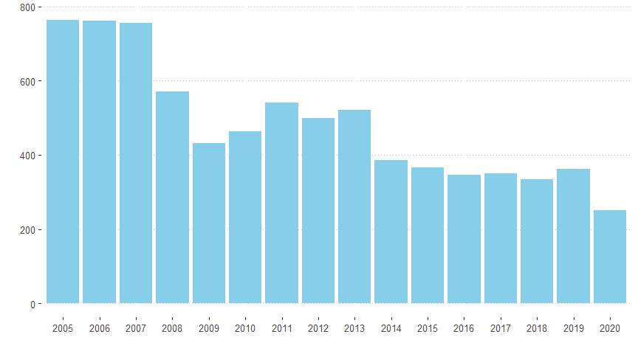 Mann-Kendall trend test

data: t1$count z = -4.2771, n = 16, p-value = 1.893e-05 alternative hypothesis: true S is not equal to 0 sample estimates: S varS tau -96.0000 493.3333 -0.8000

The output of Mann-Kendall trend test is -0.8, which indicates a strong, monotonic decrease in annual incidence over the 16 years observed time period. This degree of negative monotonicity is significant with the p-value of 1.893e-05. This indicates indicate strong evidence against the null hypothesis, supporting the presence of a trend. The limitations of this test in the trend analysis sense is that it does not provide any insight into the magnitude of the trend.While it confirms the presence of a monotonic trend, it doesn't quantify how much the variable is changing over time. It's a powerful test for trend detection but might not be sufficient if detailed information about the trend magnitude is needed.

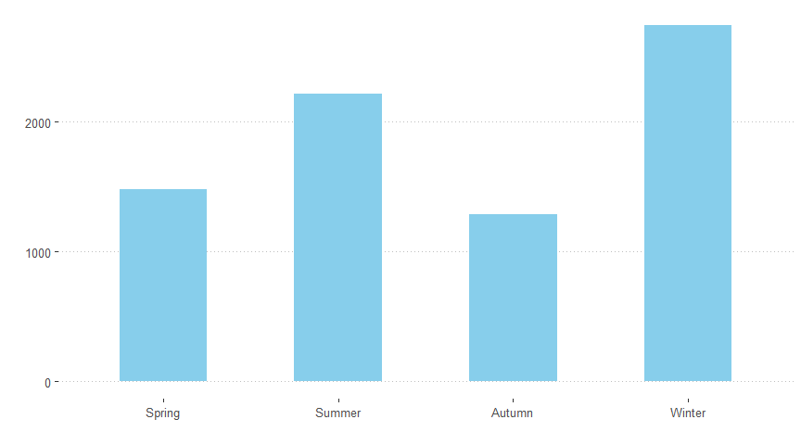 Mann-Kendall trend test

data: t2$count z = 0.33968, n = 4, p-value = 0.7341 alternative hypothesis: true S is not equal to 0 sample estimates: S varS tau 2.0000000 8.6666667 0.3333333

We observe a seasonal variation in the occurrence of HFRS, with a higher incidence during winter (December, January, February), followed by summer (June, July, August). There is no noticeable difference in HFRS occurrence between spring (March, April, May) and autumn (September, October, November).

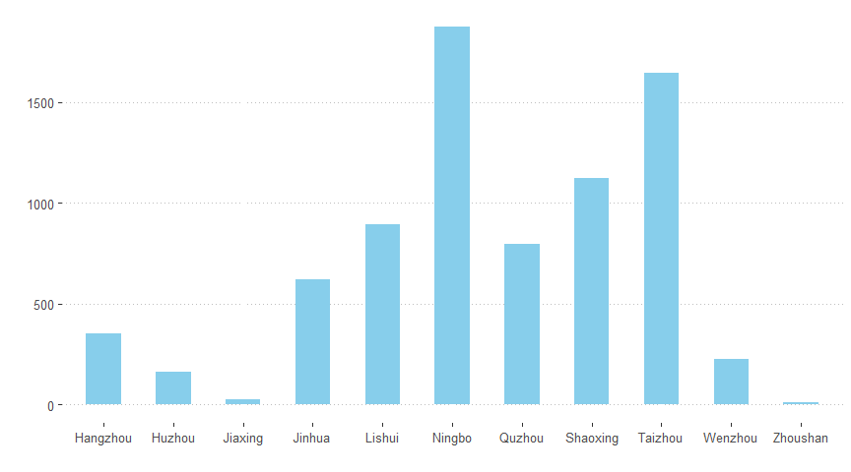

Spatial distribution: HFRS cases have been reported in all 11 cities, with the top three cities in terms of cumulative cases and their respective proportions being Ningbo (1,875 cases, 24.27%), Taizhou (1,642 cases, 21.25%), and Shaoxing (1,123 cases, 14.54%). High-incidence counties (cities, districts) for annual incidence rates are mainly distributed in the eastern, western, central, and southwestern regions of Zhejiang Province.

The provided chart illustrates the distribution of disease incidence categorized by occupation (farmer, unemployment, worker, and others) over the specified years. It is evident that the most prevalent group is comprised of farmers, constituting 26% of the total cases. The subsequent largest category is labeled as “others.” Furthermore, notable trends emerge, particularly from 2016 to 2020, where the unemployment category exhibits a discernible escalation in risk.

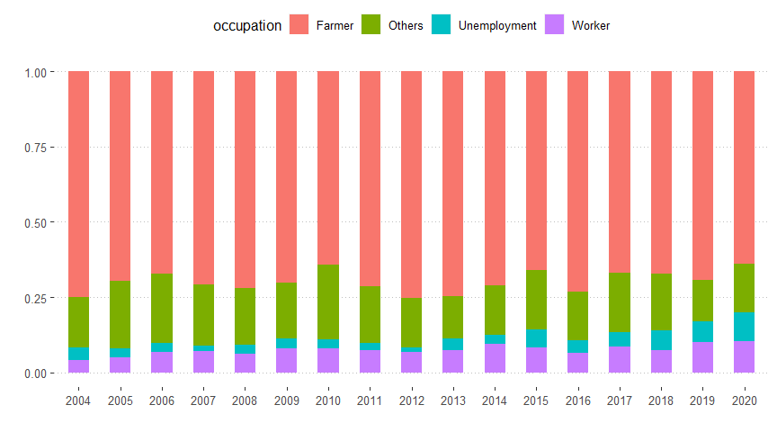

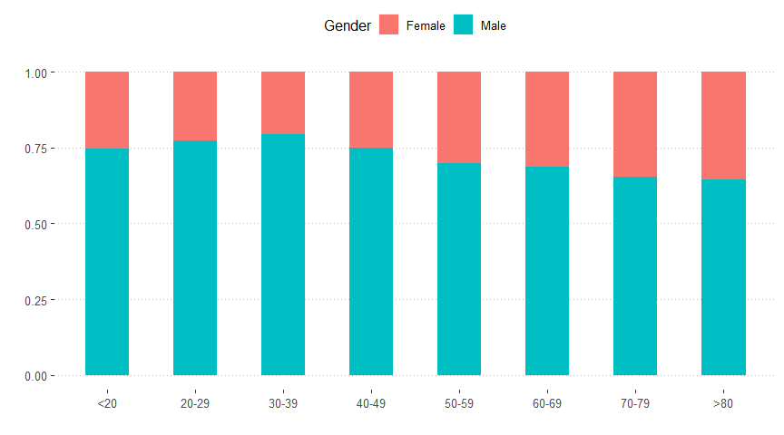

Population Distribution: among the 7,724 cases, the male-to-female ratio is 2.73:1 (5,656:2,068). The distribution by age groups is as follows: ≤20 years old, 261 cases (3.38%); 21-30 years old, 797 cases (10.32%); 31-40 years old, 1,492 cases (19.32%); 41-50 years old, 1,954 cases (25.30%); 51-60 years old, 1,806 cases (23.38%); 61-70 years old, 948 cases (12.27%); and >70 years old, 466 cases (6.03%), with the 41-70 age group accounting for 60.95%. The majority of cases are reported in individuals with an occupation as farmers, accounting for 69.89% (5,398/7,724). Upon scrutinizing age groups and gender, it becomes evident that approximately 75% of cases can be attributed to a particular age group. Moreover, a conspicuous trend emerges, indicating that as women age, they exhibit a higher likelihood of contracting HFRS in comparison to men.

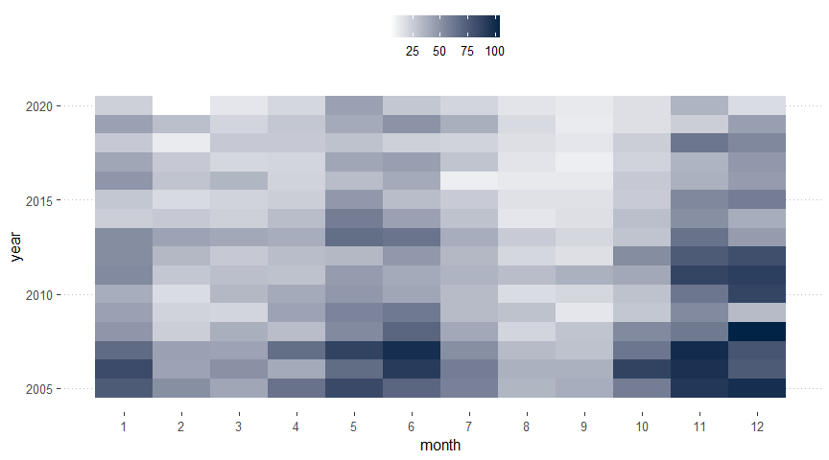

The heat map illustrates elevated incidence rates in May, June, November, and December compared to other months throughout the year. Notably, from 2005 to 2020, there is a discernible decrease in overall incidences.

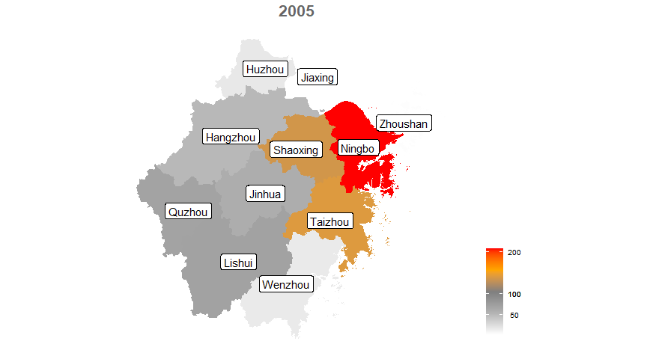 Moran I test under randomisation

data: s1$count  
weights: lw

Moran I statistic standard deviate = 2.748, p-value = 0.002998 alternative hypothesis: greater sample estimates: Moran I statistic Expectation Variance 0.43009770 -0.11111111 0.03878898

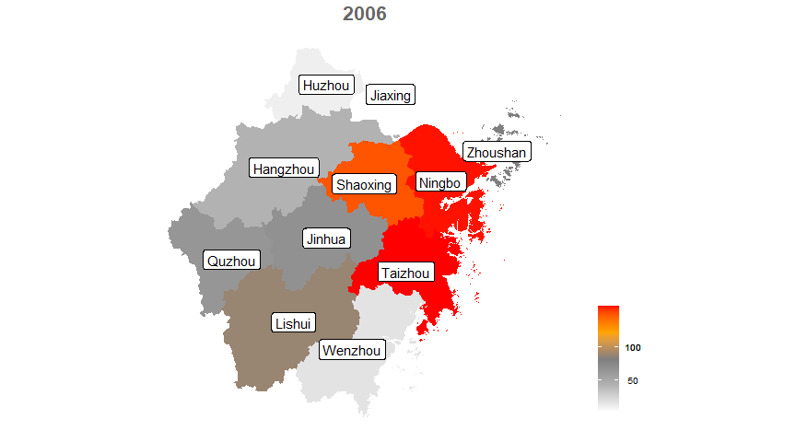 Moran I test under randomisation

data: s1$count  
weights: lw

Moran I statistic standard deviate = 2.6521, p-value = 0.004 alternative hypothesis: greater sample estimates: Moran I statistic Expectation Variance 0.44952824 -0.11111111 0.04468889

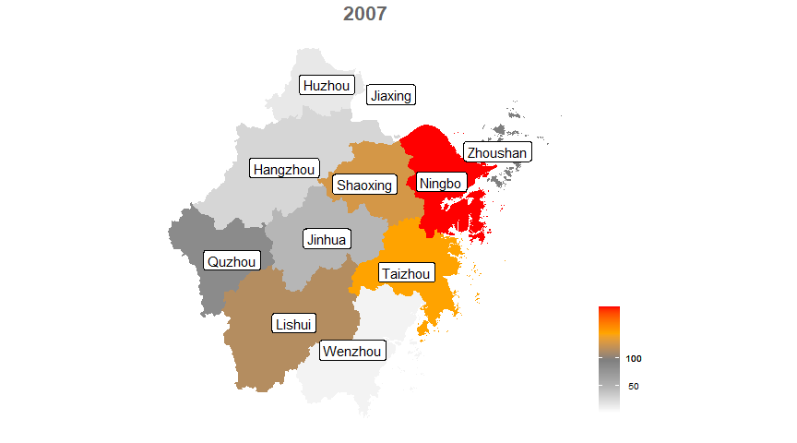 Moran I test under randomisation

data: s1$count  
weights: lw

Moran I statistic standard deviate = 2.2461, p-value = 0.01235 alternative hypothesis: greater sample estimates: Moran I statistic Expectation Variance 0.35674820 -0.11111111 0.04338647

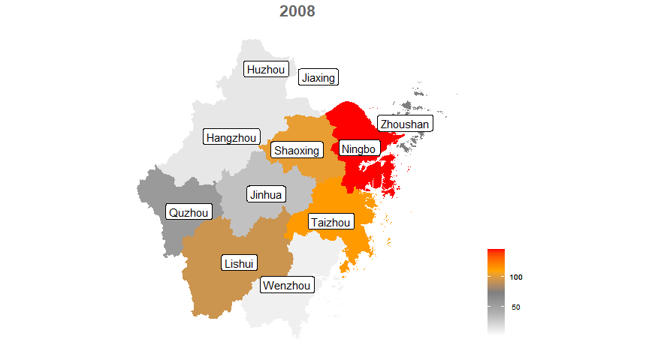 Moran I test under randomisation

data: s1$count  
weights: lw

Moran I statistic standard deviate = 2.2591, p-value = 0.01194 alternative hypothesis: greater sample estimates: Moran I statistic Expectation Variance 0.36518389 -0.11111111 0.04445264

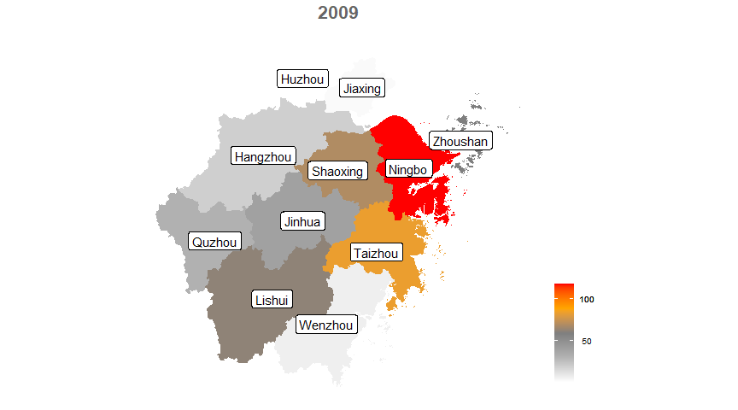 Moran I test under randomisation

data: s1$count  
weights: lw

Moran I statistic standard deviate = 2.5805, p-value = 0.004933 alternative hypothesis: greater sample estimates: Moran I statistic Expectation Variance 0.40999314 -0.11111111 0.04077952

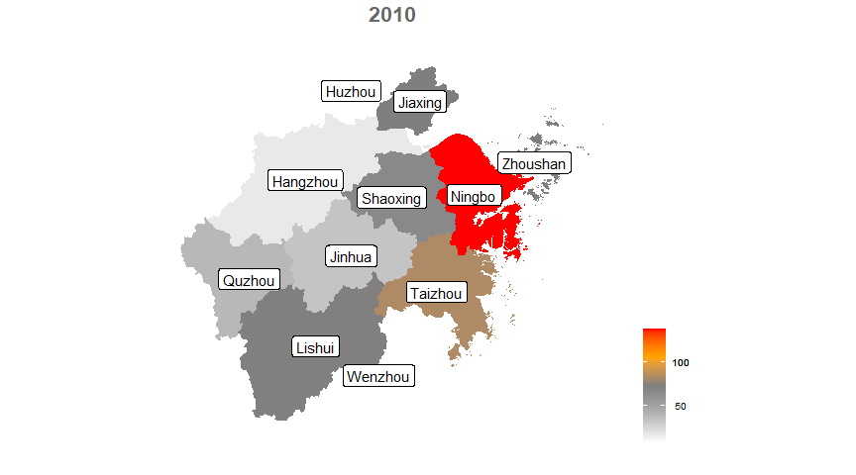 Moran I test under randomisation

data: s1$count  
weights: lw

Moran I statistic standard deviate = 1.7304, p-value = 0.04178 alternative hypothesis: greater sample estimates: Moran I statistic Expectation Variance 0.22668806 -0.12500000 0.04130615

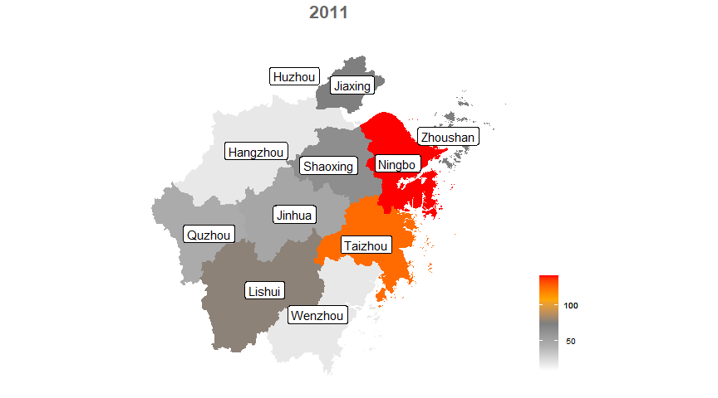 Moran I test under randomisation

data: s1$count  
weights: lw

Moran I statistic standard deviate = 1.8505, p-value = 0.03212 alternative hypothesis: greater sample estimates: Moran I statistic Expectation Variance 0.27429350 -0.12500000 0.04655861

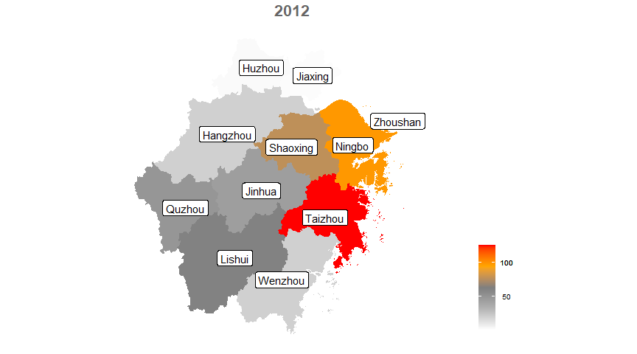 Moran I test under randomisation

data: s1$count  
weights: lw

Moran I statistic standard deviate = 2.7108, p-value = 0.003356 alternative hypothesis: greater sample estimates: Moran I statistic Expectation Variance 0.43927615 -0.11111111 0.04122291

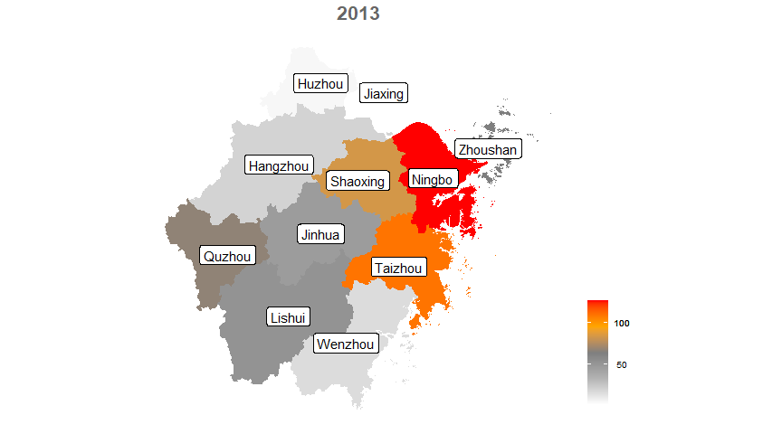 Moran I test under randomisation

data: s1$count  
weights: lw

Moran I statistic standard deviate = 2.711, p-value = 0.003354 alternative hypothesis: greater sample estimates: Moran I statistic Expectation Variance 0.45099841 -0.11111111 0.04299012

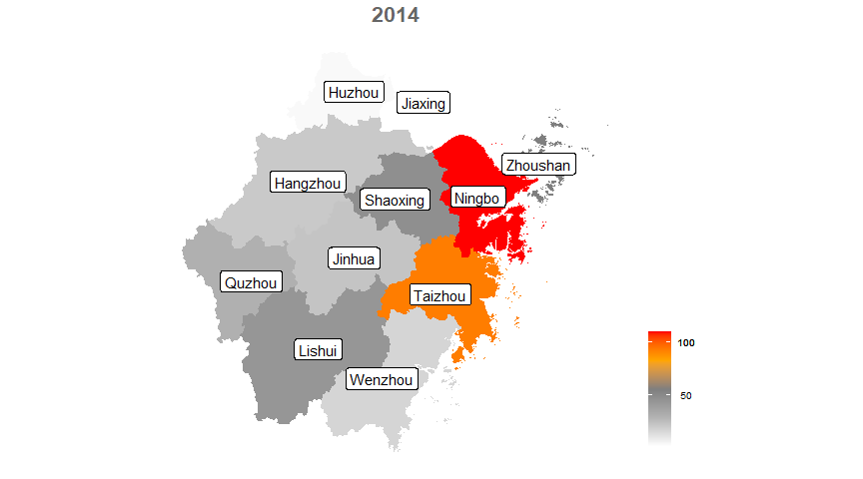 Moran I test under randomisation

data: s1$count  
weights: lw

Moran I statistic standard deviate = 2.5283, p-value = 0.005731 alternative hypothesis: greater sample estimates: Moran I statistic Expectation Variance 0.38024984 -0.11111111 0.03777069

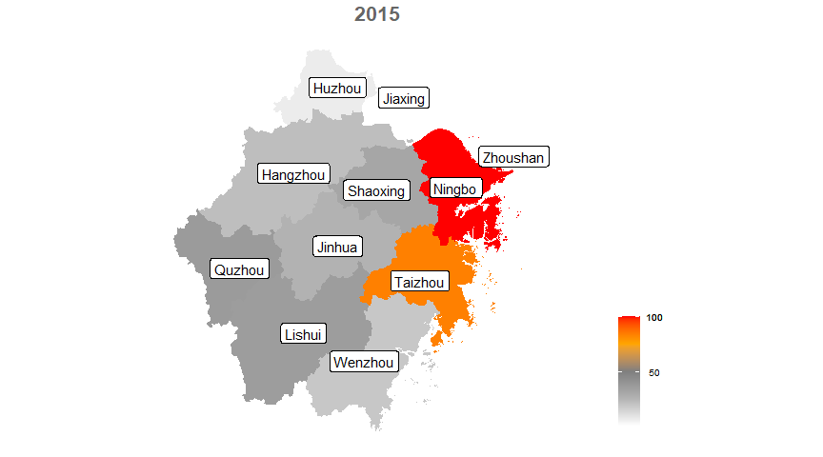 Moran I test under randomisation

data: s1$count  
weights: lw

Moran I statistic standard deviate = 2.2212, p-value = 0.01317 alternative hypothesis: greater sample estimates: Moran I statistic Expectation Variance 0.3122121 -0.1111111 0.0363231

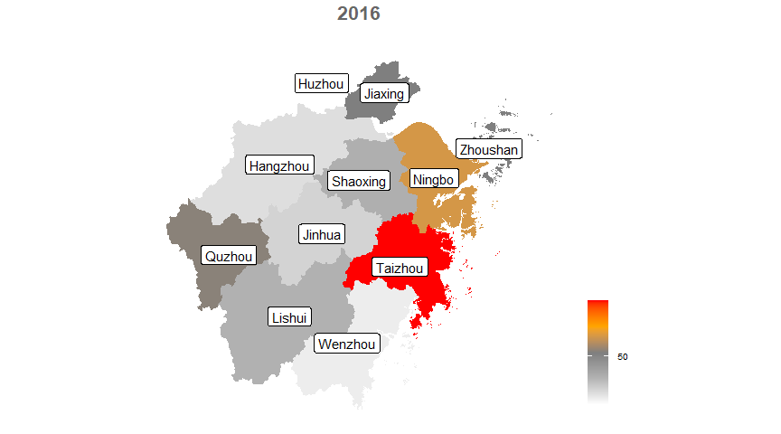 Moran I test under randomisation

data: s1$count  
weights: lw

Moran I statistic standard deviate = 0.69001, p-value = 0.2451 alternative hypothesis: greater sample estimates: Moran I statistic Expectation Variance 0.01493729 -0.12500000 0.04112978

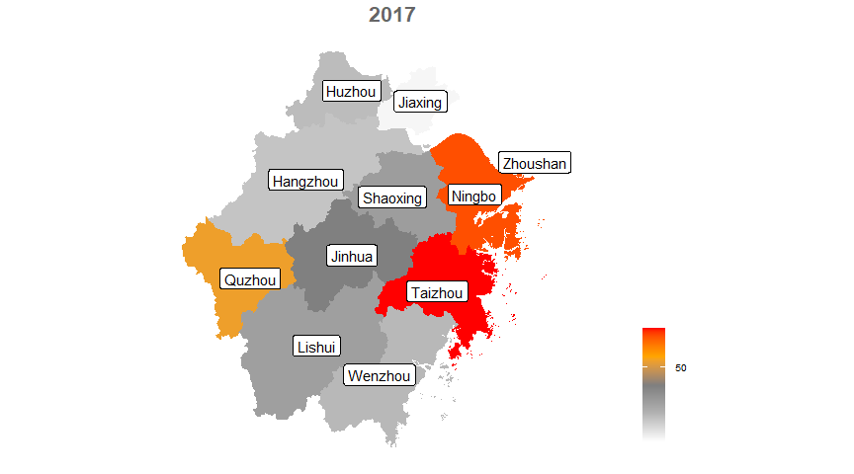 Moran I test under randomisation

data: s1$count  
weights: lw

Moran I statistic standard deviate = 1.6291, p-value = 0.05165 alternative hypothesis: greater sample estimates: Moran I statistic Expectation Variance 0.22307774 -0.11111111 0.04208121

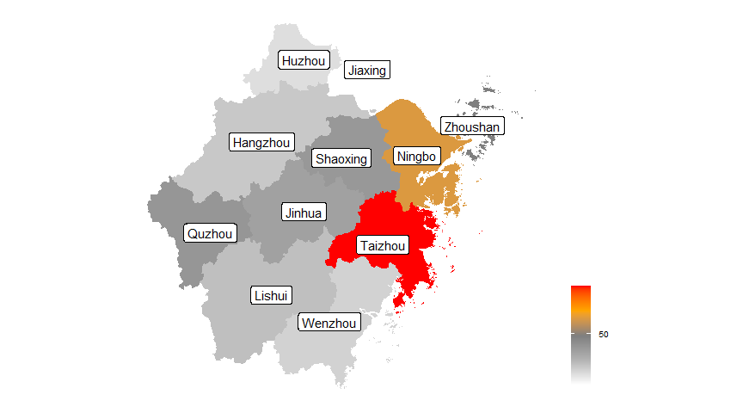 Moran I test under randomisation

data: s1$count  
weights: lw

Moran I statistic standard deviate = 1.975, p-value = 0.02413 alternative hypothesis: greater sample estimates: Moran I statistic Expectation Variance 0.24842724 -0.11111111 0.03313982

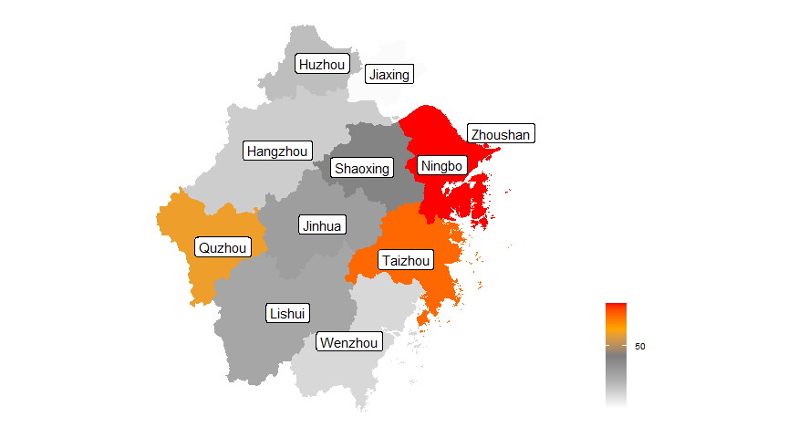 Moran I test under randomisation

data: s1$count  
weights: lw

Moran I statistic standard deviate = 1.7027, p-value = 0.04432 alternative hypothesis: greater sample estimates: Moran I statistic Expectation Variance 0.23966677 -0.11111111 0.04244315

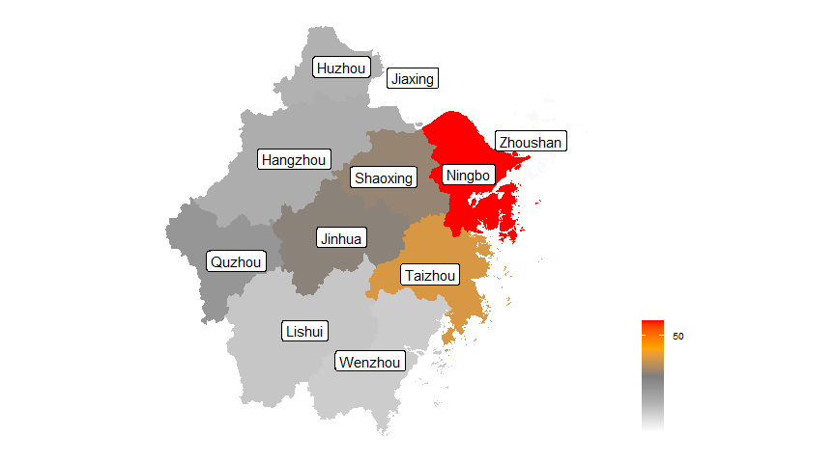 Moran I test under randomisation

data: s1$count  
weights: lw

Moran I statistic standard deviate = 2.3565, p-value = 0.009225 alternative hypothesis: greater sample estimates: Moran I statistic Expectation Variance 0.33909411 -0.11111111 0.03650034

Spatial Distribution: HFRS cases have been reported in 11 cities, with the top three cities in terms of cumulative cases and composition being Ningbo City (1,875 cases, 24.27%), Taizhou City (1,642 cases, 21.25%), and Shaoxing City (1,123 cases, 14.54%). The top five counties (cities, districts) in terms of cumulative cases are Tiantai County (606 cases), Longquan City (490 cases), Yinzhou District (447 cases), Zhuji City (407 cases), and Kaihua County (402 cases), while Haiyan County and Shengsi County have not reported any cases. We observed dynamic variations on the spatial changes of color indicators from 2005 to 2020. Descriptive statistics suggest that counties (cities, districts) with high incidence rates over the years are predominantly distributed in the eastern, western, central, and southwestern regions of Zhejiang Province. We also conduct a Moran test for each year, obtaining similar results indicating spatial correlation. However, we exclude Zhoushan City from the analysis due to its island status, signifying isolation from other cities.

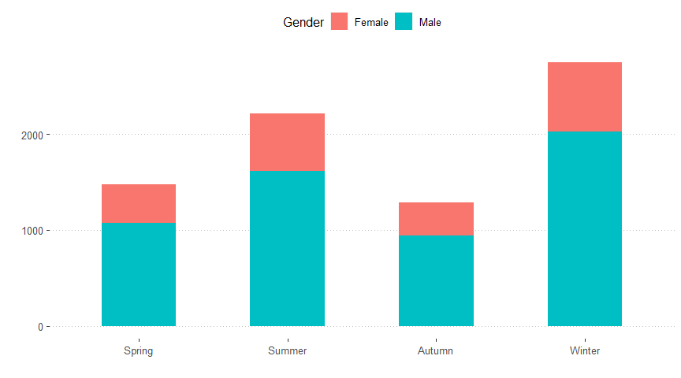

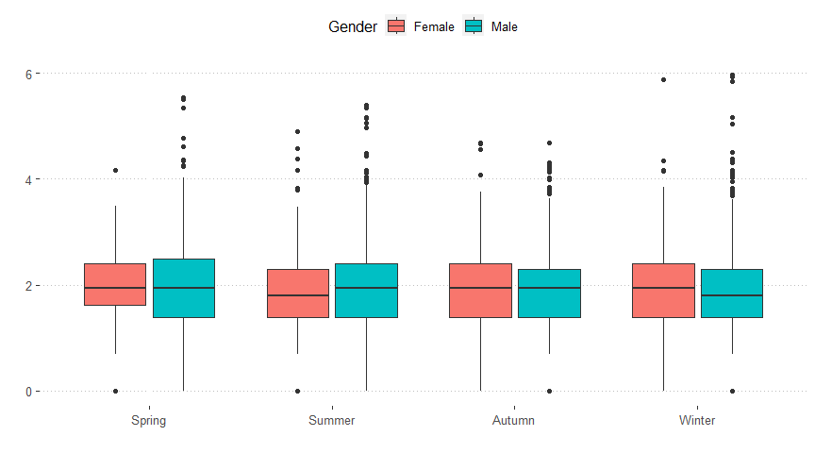 Df Sum Sq Mean Sq F value Pr(>F)  
Illness.season 3 7 2.3801 2.81 0.038 * Gender 1 0 0.0849 0.10 0.752  
Residuals 7719 6539 0.8471  
— Signif. codes: 0 ‘***’ 0.001 ’****’ 0.01 ’*’ 0.05 ‘.’ 0.1 ’ ’ 1

We also analyzed the logarithmic transformation of the difference between diagnosis time and the onset of illness. Boxplots were created to visualize it. A two-way ANOVA was performed to test for the the effect. From the ANOVA table, we can conclude that only the season of illness is statistically significant. There is no significant difference in this time difference based on gender.

Spatial Autocorrelation: The global Moran’s I coefficient is consistently greater than 0 for all years, with most years having a p-value less than 0.05. This indicates a significant positive spatial autocorrelation of HFRS incidence at the county level in Zhejiang Province for most years.

In summary, from 2004 to 2020, HFRS primarily affected middle-aged and elderly individuals, males, and farmers in Zhejiang Province. Outbreaks were more common in the eastern regions during late spring, early summer, and winter. It is recommended to implement precision control measures for key populations in high-risk areas before the epidemic season arrives. In these key areas, a combination of health education and public hygiene campaigns should be carried out as comprehensive preventive measures. Continuous monitoring of inter-species epidemics among animals is essential for effectively safeguarding the health of high-risk populations.

| **Characteristic** | **N = 7,700**1 |
| --- | --- |
| aqi | 73(20) 70[60,81] |
| pm2_5 | 41(20) 38[27,50] |
| pm10 | 65(27) 61[47,76] |
| SO₂ | 13(10) 10[7,15] |
| NO₂ | 35(14) 33[26,43] |
| co | 0.81(0.23) 0.80[0.70,0.90] |
| O₃ | 89(30) 91[65,111] |
| Temperature | 17(8) 17[10,24] |
| Humidity | 75(6) 75[70,79] |
| 1Mean(SD) Median[25%,75%] |

The table presents descriptive statistics regarding the characteristics of air pollution and meteorological factors, such as temperature and humidity, in Zhejiang province from 2013 to 2020. The average annual concentrations of PM2.5, PM10, SO₂, NO₂, and CO were 41 μg/m3, 65 μg/m3, 13 μg/m3, 35 μg/m3, and 0.81 mg/m3, respectively, while the daytime 8-hour mean concentration of O₃ was 89 mg/m3. The monthly PM2.5 and PM10 readings were significantly above the 2018 China Guidelines II threshold. A clear seasonal pattern can be seen in the boxplots showing the monthly fluctuation of air pollution concentrations. PM2.5, PM10, and NO₂ concentration peaks primarily occurred in December and January, whereas O₃ maxima transpired from May to August in late spring to late summer. The mean temperature is 17 Celsius, standard deviation 8. The average humidity is 72 g/m3 with standard deviation 6. The average temperature, which reminds that in the areas where temperature is suitable, personal protection should be taken when going out as to avoid contact with rodents.

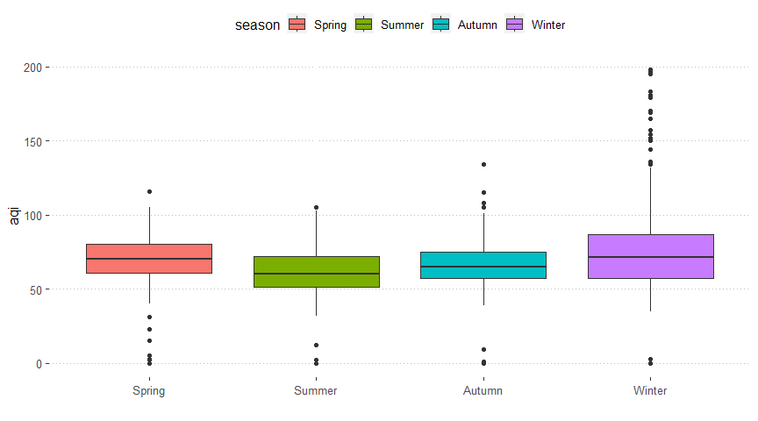



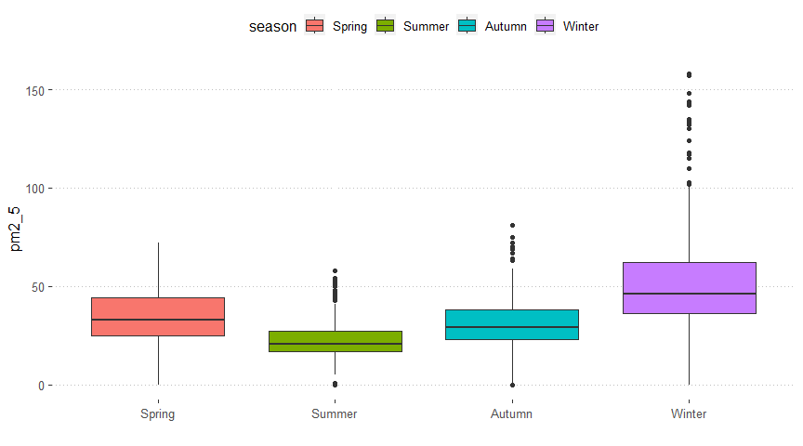 Df Sum Sq Mean Sq F value Pr(>F)  
airdata$season 3 172580 57527 205.1 <2e-16 *** Residuals 1695 475434 280  
— Signif. codes: 0 ‘***’ 0.001 ’****’ 0.01 ’*’ 0.05 ‘.’ 0.1 ’ ’ 1

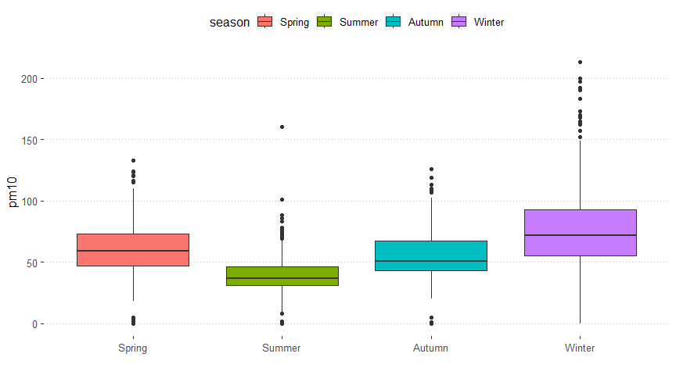 Df Sum Sq Mean Sq F value Pr(>F)  
airdata$season 3 304300 101433 177.6 <2e-16 *** Residuals 1695 968094 571  
— Signif. codes: 0 ‘***’ 0.001 ’****’ 0.01 ’*’ 0.05 ‘.’ 0.1 ’ ’ 1

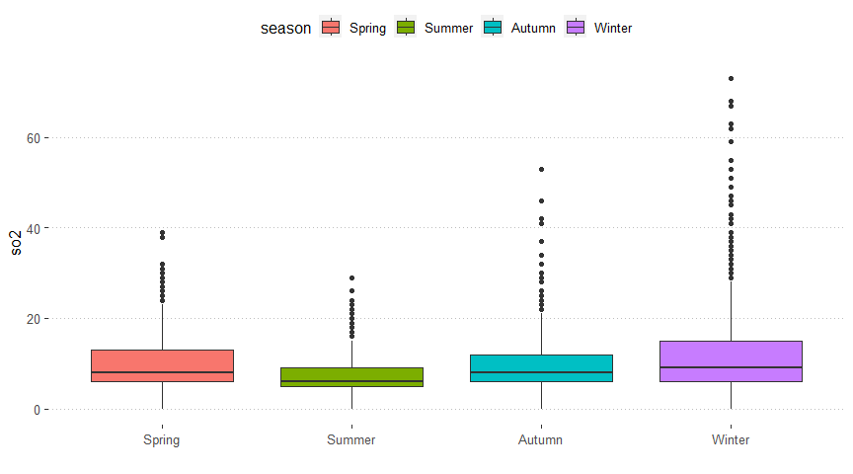 Df Sum Sq Mean Sq F value Pr(>F)  
airdata$season 3 172580 57527 205.1 <2e-16 *** Residuals 1695 475434 280  
— Signif. codes: 0 ‘***’ 0.001 ’****’ 0.01 ’*’ 0.05 ‘.’ 0.1 ’ ’ 1

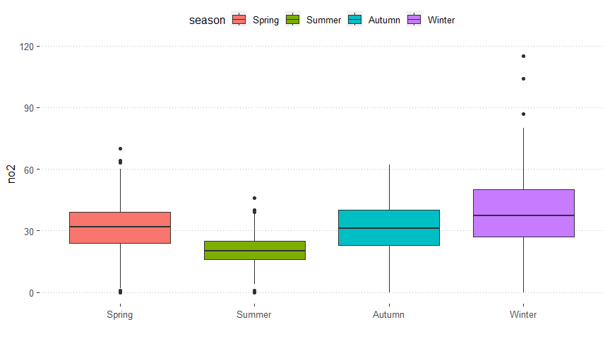 Df Sum Sq Mean Sq F value Pr(>F)  
airdata$season 3 71593 23864 151.9 <2e-16 *** Residuals 1695 266308 157  
— Signif. codes: 0 ‘***’ 0.001 ’****’ 0.01 ’*’ 0.05 ‘.’ 0.1 ’ ’ 1

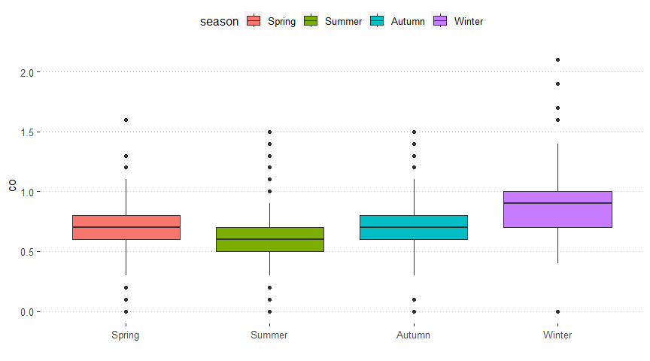 Df Sum Sq Mean Sq F value Pr(>F)  
airdata$season 3 15.26 5.088 92.41 <2e-16 *** Residuals 1695 93.33 0.055  
— Signif. codes: 0 ‘***’ 0.001 ’****’ 0.01 ’*’ 0.05 ‘.’ 0.1 ’ ’ 1

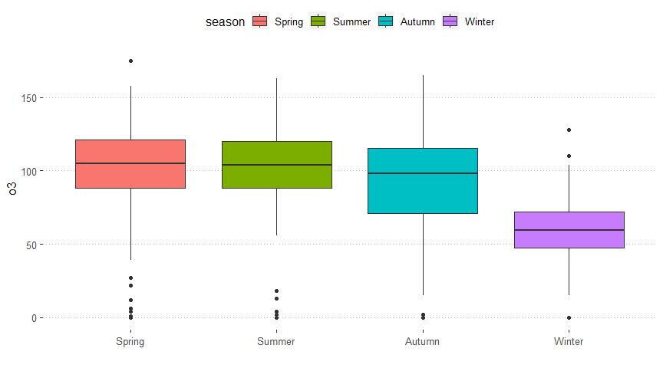 Df Sum Sq Mean Sq F value Pr(>F)  
airdata$season 3 540654 180218 259.4 <2e-16 *** Residuals 1695 1177809 695  
— Signif. codes: 0 ‘***’ 0.001 ’****’ 0.01 ’*’ 0.05 ‘.’ 0.1 ’ ’ 1

The relationship between air pollutants and HFRS. We discovered significant associations between HFRS incidence and three of the six air pollutants. It was observed between HFRS incidence and monthly Air Quality Index (AQI) (r = 0.27), Nitrogen Dioxide (NO₂) (r = 0.42), and Sulfur Dioxide (SO₂) (r = 0.25). The temperature was negatively correlated with the incidence and we did not find that humidity has any association with the HFRS incidence.

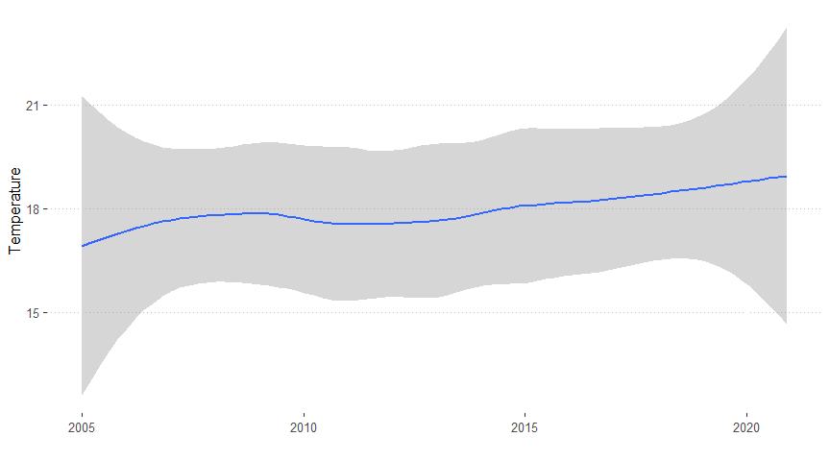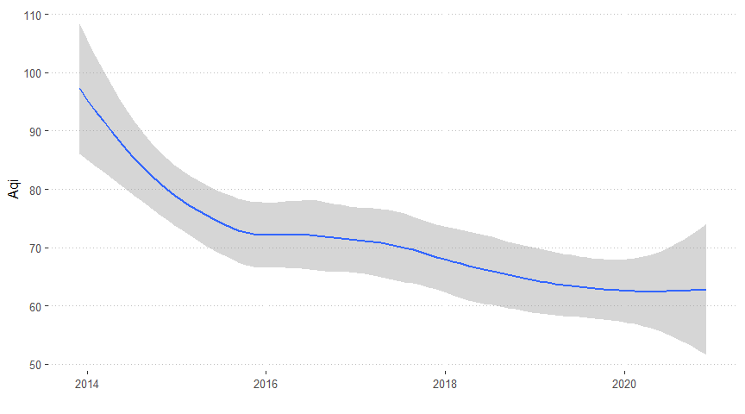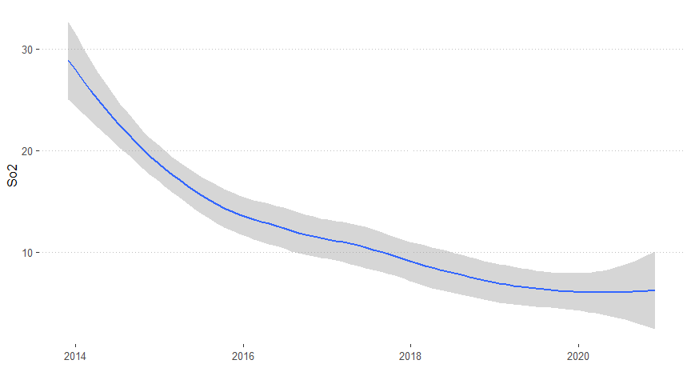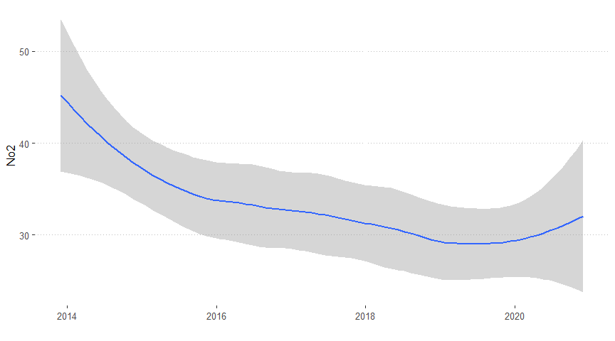

The density plot visually depicts the distribution’s shape, aiding in the identification of symmetry, left or right skewness, and whether it is unimodal or bimodal. Information about the spread or variability of the data is conveyed by the width of the density plot, where a broader plot suggests higher variability, whereas a narrower plot suggests lower variability.

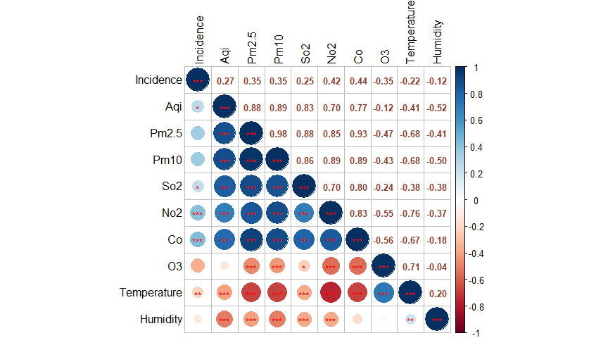

In our analysis, we aggregated the data at a monthly level across all cities. Overall, we observed a noteworthy linear positive correlation between the incidence of HFRS and AQI (r = 0.27), SO₂ (r = 0.25), and NO₂ (r = 0.42), and a significant negative linear correlation with temperature (r = -0.22). However, there were no significant linear correlations with other variables such as O₃ and humidity. The identified significant variables, including AQI, SO₂, NO₂, and temperature, may be considered for inclusion in our model. As mentioned earlier, temperature is a crucial factor contributing to the spread of HFRS.

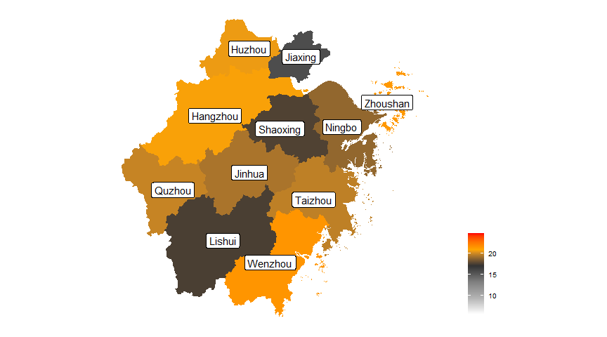

The temperature across the year in Zhejiang shows that on average the northwest (Zhangzhou, Huzhou) and southern areas (Wenzhou) have higher temperature compared to other regions, such as the northeast (Ningbo).

# Discussion

From the paper by Zhang et.al 2021[16], they analyze the changing epidemiology of HFRS in Southeastern China during 1963–2020: A retrospective analysis of surveillance data by Zhang et.al 2021. They used a space-time analysis for counties before and after the changes in policies and interventions to examine the effects of those changes on HFRS epidemics at the county level. The HFRS epidemic in Zhejiang Province can be divided into five stages. (1) 1963-1978: Period of Scattered Outbreaks (2) 1979-1986: Rapid Increase in Epidemic (3) 1987-1995: Rapid Decline in Epidemic (4) 1996-2004: Sustained Decline in Epidemic (5) 2005-2020: Continued Scattered Outbreaks. While we cannot solely focus on the political impact on the outbreaks of HFRS, we do believe that economic factors, air quality play and meteorological factors play a significant role.

Cases have been reported consistently[17]. The high incidence seasons of HFRS are closely related to the nature of the epidemic source. Zhejiang Province is classified as a mixed epidemic area with both domestic and wild rodents. There are two peaks in incidence each year, during the summer and winter. In most years, the winter peak is higher than the summer peak, which aligns with previous research findings. Studies indicate that the summer peak is primarily associated with indoor infections resulting from the reproduction of domestic rodents, while the winter peak is mainly linked to outdoor labor involving contact with wild rodents. Similar to previous research conclusions, this study observes that the epidemic source area of HFRS in Zhejiang Province has gradually expanded from the northern region to the central region. The eastern and western regions have consistently been high-incidence areas. HFRS is a naturally occurring zoonotic disease, and the main hosts in Zhejiang Province are black-striped field mice and brown rats, widely distributed in the hilly areas of both eastern and western regions. This study finds that the high-risk population for HFRS in Zhejiang Province is mainly composed of farmers and individuals aged 60 and above. This is related to the higher density of rodent populations in rural areas and the frequent contact between farmers and rodent populations, suggesting the need to expand the target population for HFRS vaccination.

Several constraints in our research merit attention. Firstly, the absence of air pollutants data for the years 2005–2012 stems from the initiation of the national air quality surveillance network. We cannot precisely merge the data from the two sources, resulting in missing data. Secondly, the air quality data is at the city level rather than the county level. However, we observed that farmers were more exposed to the infection, it is necessary to analyze whether there is a difference in air quality between urban and rural areas. Thirdly, the lack of precise quantification for social and economic status, available health services, and hygiene is due to the unavailability of relevant data. The occupation status cannot is not enough. Fourthly, our study relied on monthly data, preventing an in-depth exploration of the immediate impact of meteorological conditions and air pollutants on HFRS. Additionally, we lack access to economic data, including GDP and other economic indicators. As the spread of HFRS is through rodents, farms are the most at-risk groups for exposure. We believe that places with more industry and tourism and less agriculture and farming are likely to have a lower risk.

In most years, there is significant spatial autocorrelation in Zhejiang Province. Local spatial autocorrelation results show that the hotspots initially increase and then decrease, maintaining relatively fixed characteristics. These hotspots are concentrated in the eastern, western, central, and southwestern regions of Zhejiang Province. The spatial autocorrelation results align with the distribution of annual incidence rates in Zhejiang Province. High-incidence areas are mainly in the western and eastern regions, suggesting that adjacent areas to local spatial autocorrelation regions also carry some risk. The application of spatio temporal cluster analysis is extensive, with applications in various infectious disease fields such as HFRS with thrombocytopenia syndrome, typhoid, and hand, foot, and mouth disease. Previous research indicates that the HFRS epidemic area in Zhejiang Province is gradually expanding. There is also research from Zhang et. al [9] They use spatial cluster areas, local spatial autocorrelation regions, and incidence rate distribution detected by SaTScan software, the findings between us are consistent.

The paper also shows that the basic alignment indicates that the key areas for HFRS prevention and control in Zhejiang Province are in the central, eastern, and western regions. The results of retrospective spatio cluster analysis show that the detected high-incidence period is from 2005 to 2017, which is consistent with the distribution of incidence rates in Zhejiang Province. After 2017, the incidence rate in the entire province shows a decreasing trend. Taizhou City, Shaoxing City, and Ningbo City have consistently been high-incidence areas in Zhejiang Province. Local measures targeting key populations should be implemented in these areas based on the seasonal prevalence.

Zhang et.al [2] analysed the correlations between HFRS and meteorological factors, as well as per capital GDP. Several grouping structures were used in their correlation analyses, effectively preventing pseudo-regression. Future epidemics were predicted through the application of time series analysis techniques. By calibrating an autoregressive integrated moving average-support vector machine (ARIMA-SVM) combination model, we were able to forecast HFRS trends.The occurrence of infectious diseases is influenced by various factors, including environmental, meteorological, and socio-economic factors. This study analyzes the spatio distribution characteristics and trends of spatio clustering changes in HFRS in Zhejiang Province. It provides data support for in-depth research on the epidemic characteristics, influencing factors, the construction of predictive warning models, and precision prevention and control of HFRS.

The air quality as an air pollution index, consisting of fine particles suspended in a gas or liquid, underscores its potential as an indicator for hantavirus transmission. The existing body of evidence strongly supports the link between air pollution and respiratory infections, primarily attributed to immune system modulation. Similarly, air pollution might influence the frequency of HFRS cases by altering viral infectivity and immunity in both human and rodent populations. However, these potential mechanisms have been primarily explored in the context of respiratory infections, and a comprehensive understanding of the involved processes is yet to be achieved.

While our findings affirm an association between air pollutants, temperature and HFRS, we refrain from characterizing it as a causal effect. Statistical differences between temperature were observed; however, caution should be exercised in drawing causal inferences. Further research is essential to deepen our understanding of the intricate relationship between air pollutants and HFRS.

# Conclusion

Our comprehensive investigation delved into the intricate dynamics between air pollutants, temperature variations, and the incidence of Hantavirus Pulmonary Syndrome (HFRS). Spanning the period from 2005 to 2020, our findings underscored a notable predilection of HFRS for impacting middle-aged and elderly demographics, particularly males and individuals engaged in agricultural occupations, within the geographic confines of Zhejiang Province.

There was a clear seasonal trend that the eastern area experienced higher incidence rates of HFRS in the transitional months of late spring to early summer and winter. The complex relationship between climatic conditions and disease prevalence is highlighted by this temporal association.

We therefore recommend the deliberate application of precision control and preventative strategies in light of our findings. In areas where the illness offers a significant threat, these interventions should specifically be designed to target key populations designated as high-risk, which generally include males, middle-aged and older adults, and those involved in farming. In order to prevent the development of HFRS and limit its effects, it is imperative that these preventive measures be put in place well in advance of the epidemic season. This will protect the population's health and well-being in Zhejiang Province.

# Reference

[1] Zhang R, Zhang N, Liu Y, Liu T, Sun J, Ling F and Wang Z (2022) Factors associated with hemorrhagic fever with renal syndrome based maximum entropy model in Zhejiang Province, China. Front. Med. 9:967554. doi: 10.3389/fmed.2022.967554

[2] He J, Christakos G, Zhang W and Wang Y (2017) A Space-Time Study of Hemorrhagic Fever with Renal Syndrome (HFRS) and Its Climatic Associations in Heilongjiang Province, China. Front. Appl. Math. Stat. 3:16. doi: 10.3389/fams.2017.00016

[3] Zhang C, Fu X, Zhang Y, Nie C, Li L, Cao H, Wang J, Wang B, Yi S, Ye Z. Epidemiological and time series analysis of haemorrhagic fever with renal syndrome from 2004 to 2017 in Shandong Province, China. Sci Rep. 2019 Oct 10;9(1):14644. doi: 10.1038/s41598-019-50878-7. PMID: 31601887; PMCID: PMC6787217.

[4] Wang Q, Yue M, Yao P, Zhu C, Ai L, Hu D, Zhang B, Yang Z, Yang X, Luo F, Wang C, Hou W and Tan W (2021) Epidemic Trend and Molecular Evolution of HV Family in the Main Hantavirus Epidemic Areas From 2004 to 2016, in P.R. China. Front. Cell. Infect. Microbiol. 10:584814. doi: 10.3389/fcimb.2020.584814

[5] Li, Shujuan & Ren, Hongyan & Hu, Wensheng & Lu, Liang & xu, Xinliang & Zhuang, Dafang & Liu, Qi-Yong. (2014). Spatiotemporal Heterogeneity Analysis of Hemorrhagic Fever with Renal Syndrome in China Using Geographically Weighted Regression Models. International journal of environmental research and public health. 11. 12129-47. 10.3390/ijerph111212129.

[6] Qian, J., Luo, C., Lv, Q. et al. Associations between ambient air pollutants and childhood hand, foot, and mouth disease in Sichuan, China: a spatiotemporal study. Sci Rep 13, 3993 (2023). <https://doi.org/10.1038/s41598-023-31035-7>

[7] Ibañez, M.V.; Martínez-Garcia, M.; Simó, A. A Review of Spatiotemporal Models for Count Data in R Packages. A Case Study of COVID-19 Data. Mathematics 2021, 9, 1538. <https://doi.org/10.3390/math9131538>

[8] Yang S, Gao Y, Liu X, Liu X, Liu Y, Metelmann S, Yuan C, Yue Y, Chen S, Liu Q. Spatiotemporal dynamics of hemorrhagic fever with renal syndrome in Jiangxi province, China. Sci Rep. 2020 Aug 31;10(1):14291. doi: 10.1038/s41598-020-70761-0. PMID: 32868784; PMCID: PMC7458912.

[9] Zhang R, Zhang N, Ling F, Liu Y, Guo S, Shi XG, Ren JP, Sun JM. [Study on epidemic trend of hemorrhagic fever with renal syndrome in Zhejiang province, 2005-2020]. Zhonghua Liu Xing Bing Xue Za Zhi. 2021 Nov 10;42(11):2030-2036. Chinese. doi: 10.3760/cma.j.cn112338-20210528-00435. PMID: 34818851.

[10] Exposure to air pollution and scarlet fever resurgence in China: a six-year surveillance study <https://doi.org/10.1038/s41467-020-17987-8>

[11] Analyzing hemorrhagic fever with renal syndrome in Hubei Province, China: a space–time cube-based approach

[12] Li S, Ren H, Hu W, et al. Spatiotemporal heterogeneity analysis of hemorrhagic fever with renal syndrome in China using geographically weighted regression models. Int J Environ Res Public Health 2014; 11: 12129–12147.

[13] Rathod, Santosha & Gurung, Bishal & Singh, Kamalesh & Ray, Mrinmoy. (2018). An improved Space-Time Autoregressive Moving Average (STARMA) model for Modelling and Forecasting of Spatio-Temporal time-series data.

[14] Nazia N, Butt ZA, Bedard ML, Tang WC, Sehar H, Law J. Methods Used in the Spatial and Spatiotemporal Analysis of COVID-19 Epidemiology: A Systematic Review. Int J Environ Res Public Health. 2022 Jul 6;19(14):8267. doi: 10.3390/ijerph19148267. PMID: 35886114; PMCID: PMC9324591.

[15] Cressie N, Calder CA, Clark JS, Ver Hoef JM, Wikle CK. Accounting for uncertainty in ecological analysis: the strengths and limitations of hierarchical statistical modeling. Ecol Appl. 2009 Apr;19(3):553-70. doi: 10.1890/07-0744.1. PMID: 19425416.

[16] Zhang R, Mao Z, Yang J, Liu S, Liu Y, et al. (2021) The changing epidemiology of hemorrhagic fever with renal syndrome in Southeastern China during 1963–2020: A retrospective analysis of surveillance data. PLOS Neglected Tropical Diseases 15(8): e0009673. <https://doi.org/10.1371/journal.pntd.0009673>

[17] Zhang S, Wang S, Yin W, Liang M, Li J, Zhang Q, Feng Z, Li D. Epidemic characteristics of hemorrhagic fever with renal syndrome in China, 2006-2012. BMC Infect Dis. 2014 Jul 11;14:384. doi: 10.1186/1471-2334-14-384. PMID: 25012160; PMCID: PMC4105051.

[18] Xu, Q., Li, R., Rutherford, S., Luo, C., Liu, Y., Wang, Z., & Li, X. (2018). Using a distributed lag non-linear model to identify impact of temperature variables on haemorrhagic fever with renal syndrome in Shandong Province. Epidemiology & Infection, 146(13), 1671-1679. <doi:10.1017/S095026881800184X>